My working days and my days off

On a working day I usually get up early. I make my bed, wash my face, put my clothes on and go to the kitchen to have breakfast. I do not like big breakfasts. I prefer a cup of tea and a sandwich.
Then I go to college. It is rather far from my house and I go there by bus. I have classes till three o'clock. Then I come home and have dinner.
After my dinner, I have a rest and then I do my homework. If I have some spare time I do some work about the house. I sweep the floor, dust the furniture and clean the carpets with the vacuum-cleaner. Sometimes I go shopping.
I usually go to bed at about ten o'clock, sometimes at eleven o'clock.
I have the only day off. It is Sunday. During the week I am very busy, so I like to have a rest on weekend. On Sunday I go for a walk with my friends, watch TV, read books, listen to the music or play my favourite computer games.

Ago - тому назад  Last week, month, year- на прошлой неделе, в прошлом месяце, году  Yesterday- вчера | Usually - обычно  Often - часто  Seldom - редко  As a rule - как правило  Every day - каждый день  Sometimes - иногда | Tomorrow- завтра  In a week - через неделю  Next month - в следующем месяце
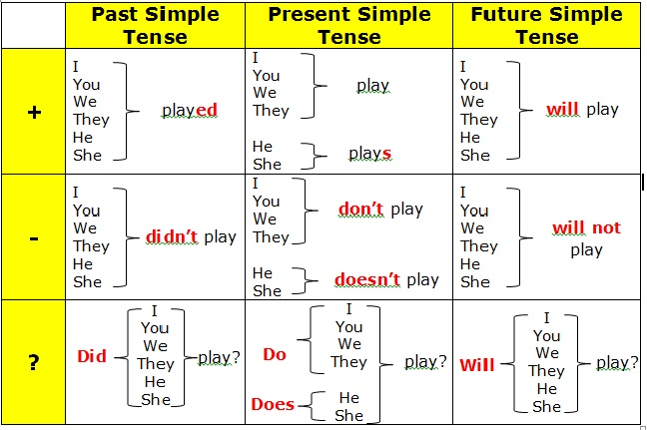
Времена группы Simple

